**Level 2 Computer Science 2021**

|  |
| --- |
| **Vision Board Web App (HTML, CSS, JS)**  Use advanced techniques to develop a digital media outcome |

AS91893 2.4 (4 Credits)

|  |  |  |
| --- | --- | --- |
| **Achievement** | **Merit** | **Excellence** |
| Use advanced techniques to develop a digital media outcome. | Use advanced techniques to develop an informed digital media outcome. | Use advanced techniques to develop a refined digital media outcome |

The digital media assessment (2.4) and the associated database assessment (2.3) form the **Vision Board** **Web App Project.**

A vision/mood board is generally a collage consisting of photos, illustrations and other graphics. It may contain some text, but it’s mainly a way to make your ideas visual and express yourself through images. Mood boards can be large enough to cover a wall or small enough to fit your screen.

(more information here: <https://setapp.com/lifestyle/tips-for-creating-mood-boards> )

Example (vision board or mood board)

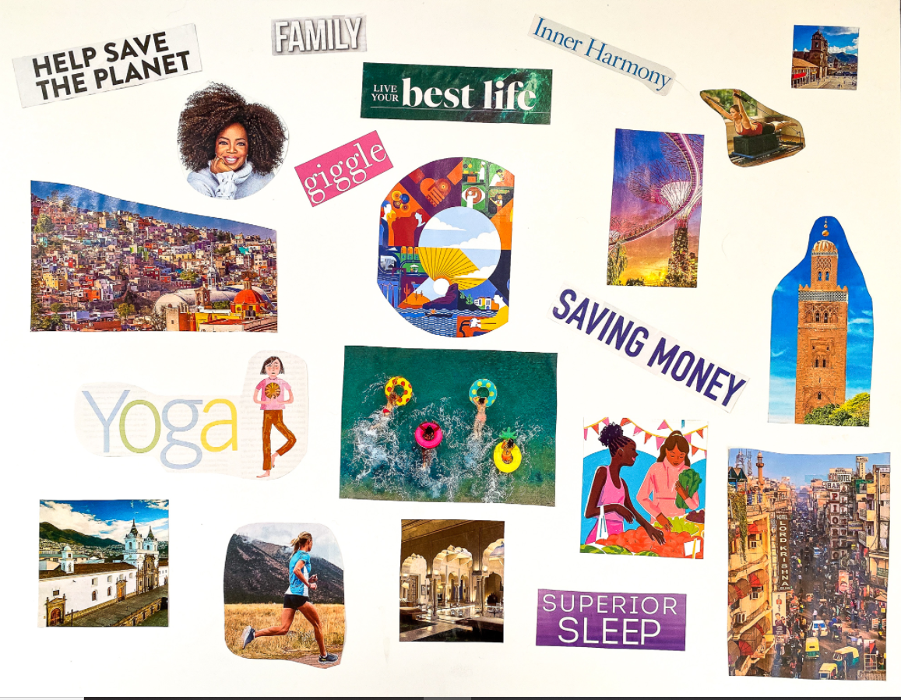

**Task (default):**Plan, design and build iteratively a functional concept/prototype vision/mood board web app that engages users through its vibrant colours and simplicity. You are to use HTML, CSS and JS libraries (if needed) to create a mobile experience which is responsive to a smartphone’s screen size. This will allow users to

* view a small list of boards already stored in a database (start with a prebuilt one at the beginning)
* log in to the web app through a form (firebase [authentication](https://firebase.google.com/docs/auth/web/start))
* make/upload images/files for their own vision board
* (option) admin users have an additional power user options (deleting boards, deleting users, etc. – up to you).

|  |
| --- |
| Functional Specifications  * 3 or more pages/windows (eg. landing page, boards list, single board layout, build your own) with a clean, modern, professional layout and colour theme * Website/app must be scalable/responsive (viewable in two or more screen sizes) * The styling must be implemented externally to ensure ease of maintenance and futureproofing * The [navigation](https://www.ramotion.com/blog/website-navigation/) must be intuitive, creative, modern * App must have a [logo](https://www.designevo.com/blog/make-logo-in-ps-without-ps-tutorial.html)/icon (provide several design ideas) or a background image/video that is original (made by you)   Aesthetic ***Specifications***   * Clean, modern, intuitive design |

**You can pitch your own brief for this standard.** Please note that you will need to submit a proposal, which includes a brief, list of specifications and your outcome must adhere to the program requirements below. Your project idea must be emailed submitted for consideration by **Friday, July 9th**. If it does not meet the requirements of Level 2 (listed below), you will be required to complete the default task (above).

## The following software, tools and advanced techniques may be of use in this project:

* Adobe XD, or [Thunkable](https://thunkable.com/#/), or equivalent for prototyping ideas
* Atom, Brackets, VSCode or Adobe Dreamweaver, Adobe Photoshop/Illustrator
* CSS flexbox layout
* Boilerplates like [Skeleton](http://getskeleton.com/#examples) or [Bootstrap](https://websitesetup.org/bootstrap-tutorial-for-beginners/)

You must submit:

* All work must be uploaded to the OLE (links, files, videos)

Authenticity:

* All work must be your own and no one else is to do any work on your project.
* You are allowed to work with the Database designer to integrate a database into your app.
* Any images or code you use that are not your own must be referenced ( as a comment in your web app, or in your documentation ).

**Success criteria for AS91893 V1**

2.4 Use advanced techniques to develop a digital media outcome (4 credits internal)

|  |  |  |  |  |  |
| --- | --- | --- | --- | --- | --- |
|  | Student/  Date | Teacher/  date | Assessment evidence | Assessment strategies | *The examples below are indicative samples only* |
|  |  |  | |  | | --- | | 1. *Use advanced techniques to develop a digital media outcome.* | | | |
| **Achieved** |  |  | I have used appropriate tools and techniques for the purpose and end users | Written documentation, screenshots, screen casts, teacher observation | *Tools/Software? Justify your choice. Insert snapshots of your workspace in your documentation.*  *Document your techniques (code/preview snapshots, before and after previews, specific html, css, javascript code)*  *Examples of* ***advanced*** *techniques include:*  *● creating or customising scripts, code or presets*  *● using a combination of steps to manipulate or enhance elements*  *● using a third-party library*  *● using composite effects*  *For example (partial evidence):*  *The student has created a web app using html/css with an external stylesheet called style.css. The material is structured and formatted using a range of tags and styles (i.e. it has clear headings, body text and lists/bullets if required). Insert snapshots/evidence here. The student has used an external library to further enhance the user’s experience.* |
|  |  | I have applied appropriate data integrity and testing procedures | Written documentation, screenshots, screen casts, teacher observation | *Evidence of data integrity: e.g. all media displays as intended (not missing or corrupted); all text, captions, tooltips appear as intended*  *Evidence of testing procedures: e.g. regular previews, html/css validation, browser and device testing*  *For example (partial evidence):*  *The site/app has been tested/previewed either in two unrelated browsers or with at least two different screen sizes. The site looks acceptable on screen on a range of screens.*  *The text has been proofread and there are no obvious spelling/grammatical issues (minor spelling/grammar issues are OK for Achieved).* |
|  |  | I have used relevant conventions for the media type | Written documentation, screenshots, screen casts | [*Usability and clarity guidelines*](https://www.orbitmedia.com/blog/web-design-standards/) *for website design: e.g. logo placement, main navigation, etc.*  [*Mobile user experience*](https://digital.gov/resources/mobile-user-experience-guidelines/) *guidelines*  [*HTML*](https://www.w3schools.com/html/html5_syntax.asp) *guidelines*  *For example (partial evidence):*  *The student has used concepts such as* [*contrast*](https://www.techrepublic.com/blog/webmaster/effective-design-principles-for-web-designers-contrast/1838)*,* [*repetition*](https://www.techrepublic.com/blog/webmaster/effective-design-principles-for-web-designers-repetition/1849)*,* [*alignment*](https://www.techrepublic.com/blog/webmaster/effective-design-principles-for-web-designers-alignment/1856)*,* [*proximity*](https://www.techrepublic.com/blog/web-designer/effective-design-principles-for-web-designers-proximity/) *and* [*white space*](https://blog.teamtreehouse.com/white-space-in-web-design-what-it-is-and-why-you-should-use-it) *to lay out their site.* |
|  |  | I have explained relevant implications | Written documentation, screenshots | *Please see Assessment Relevant Implication resource on the OLE. Student must choose specific implications relevant to the outcome, and answer concisely questions like what is copyright and why is it important; then refer to their own outcome.*  *For example (partial evidence):*  *The student has explained why* ***copyright*** *should be honoured/images should be credited.*  *They have mentioned why the site should be* ***accessible*** *for colour blind/visually impaired users.*  *They have stated why their site should be* ***easy to navigate*** *(the site may have minor navigation issues).* |
|  |  |  | |  | | --- | | 1. *Use advanced techniques to develop an informed digital media outcome.* | | | |
| **Merit** |  |  | I have used information from testing procedures to improve the quality of the outcome | Written documentation, screenshots, screen casts, teacher observation | *Keep evidence of improvements – before and after screenshots*  *For example (partial evidence):*  *The student has previewed the outcome and made changes to the layout/formatting to improve it.*  *The student has asked a volunteer to use their site and made changes based on volunteer feedback.*  *The student has previewed the site using a slightly smaller (or larger) screen and adjusted the layout to ensure the site looks acceptable on a range of wide screen devices.* |
|  |  | I have applied relevant conventions to improve the quality of the outcome | Written documentation, screenshots, screen casts, teacher observation | *For example (partial evidence):*  *The student has used fonts to ensure that the site looks consistent on all devices.*  *The student has used css to go beyond the basics – for example they have used partial transparency, rounded corners, shadows or css grid to create an aesthetically pleasing outcome.* |
|  |  | I have addressed relevant implications. | Written documentation, screenshots, screen casts, teacher observation | *For example (partial evidence):*  *The student has acknowledged and credited the source of their images (or made it clear that the images are original).*  *They have ensured that all their images have ‘alt’ tags/descriptions so that the material can be read out by screen-readers (and is thus accessible to visually impaired users).*  *The site is easy to use/navigate, as per guidelines.* |
|  |  |  | |  | | --- | | *(E) Use advanced techniques to develop a refined digital media outcome.* | | | |
| **Excellence** |  |  | I have used iterative improvement throughout the design, development and testing process to produce a high-quality outcome | Written documentation, screenshots, screen casts, teacher observation | *Clear evidence of the iterative process needs to be present:*  *e.g. Initial navigation, interim changes, final navigation*  *e.g. Initial colour scheme, interim, final changes*  *e.g. Initial layout, interim, final layout*  *For example (partial evidence):*  *The student carried out testing at key points during the creation of the website to ensure that it was fit for purpose and easy to use. They made changes* ***based on testing and feedback*** *at each cycle in an iterative loop. For instance, they checked that…*   * *navigation was intuitive* * *the material was easy to read/understand* * *the web app loaded quickly* * *usability heuristics were adhered to* * *the application of css was effective for the purpose and end-users* * *they have saved or screen shot their iterative development process.* |
|  |  | I have used efficient tools and techniques in the outcome’s production. | Written documentation, screenshots, screen casts, teacher observation | *For example (partial evidence):*   * *The student has a sensible file structure with a separate images sub-folder (and possibly sub-folders for css/js as well).* * *Html/css have been appropriately commented and/or class names are descriptive (e.g. <div class=”main”>).* * *Images have been resized and optimised.* * *Brackets shortcuts, boilerplates,* [*optimize css performance*](https://www.sitepoint.com/optimizing-css-performance/)*, etc.* |

**Final grades** will be decided using professional judgement based on a holistic examination of the evidence provided against the criteria in the Achievement Standard.